USING THE UPDATE ASSISTANT

KEEPING YOUR SOFTWARE UPDATED

Keeping your Pastel Accounting product updated, is critical to the effective running of your mission critical software. From time to time it is necessary for Softline Pastel to make available updates to our range of software. Many of these updates incorporate both, exciting changes as well as critical updates.

The updates are made available on the Pastel Cover Zone at www.pastel.co.za W y e-mail or in the monthly electronic Support Newsletter. Therefore please ensure you visit the Pastel Cove Zone regularly to ensure you are on the latest update at all times.

The updates are exclusive to Pastel Cover Subscribers (see Section X on Support Services). You can obtain your updates in 2 ways:
- Download them from the Pastel Cover Zone at www.pastel.co.za which is reliable, quick and certainly the most efficient way.
- Requesting a CD from us - the CD will not always be available from us when the update is placed on the web site, and will often only be made available a few weeks later.

What do I need to update my software?
You will require:
- Internet access
- Your product Serial Number (this can be found on the back of your DVD cover or by going to Help | About in your Pastel Accounting program.
- Your Customer Number (which is the same number used to gain access to the Support Team)
- Your Update Install Key (this is used ONLY once you have installed the update in the relevant machine/s) and can be found either on the e-mail documentation sent to you after your registration or by going to Update Details on the Pastel Cover Zone (scroll down until you see the section on Authorisation / Registration Details).

How do I download the Update?
- Go to www.pastel.co.za
- Select Customer Zone, enter your Serial Number and Customer Number
- Click on Updates and Upgrades
- Select the product category relevant to you (i.e. Partner, Express etc.)
- You will have a selection of updates to choose from, each one of these has a Readme document which details any changes that have been made to the software, it is important to read this BEFORE you proceed with your update installation.
- The file you download is a compressed file which is made up of 2 files
- When selecting the file to download, you will be asked to Open or Save.
- You will need to select the location in which you want to Save the file
- Once the download is complete, exit the Pastel web site and close your Internet Explorer

How do I update my software?
- Right click on Start, and select Explore
- Locate the file you saved in the step above.
- Double click on this file.
- An update installation screen will be displayed
- You will be prompted for the location of you Pastel product folder, browse the folder and select the Customer folder and then Updates (e.g. C:\Pastel05\Custome\Updates or C:\Xpress05\Custom\Updates)
- Click on the Finish button
- Close Windows Explorer.
- Select Start then Programs and then Softline Pastel
- Look for Pastel Partner 2005 or Pastel Xpress 2005
- Once you have selected this, click on Update Assistant

How the Update Assistant Works:
- You can then access the Update Assistant from the Start Menu the following screen will appear:

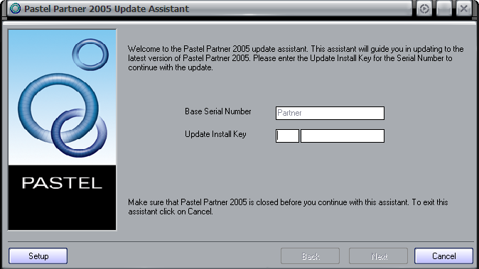

- The Base Serial Number field will automatically be populated.
- You will need to enter your Update Install key to continue.
- Click the “Next” button, following screen will appear:
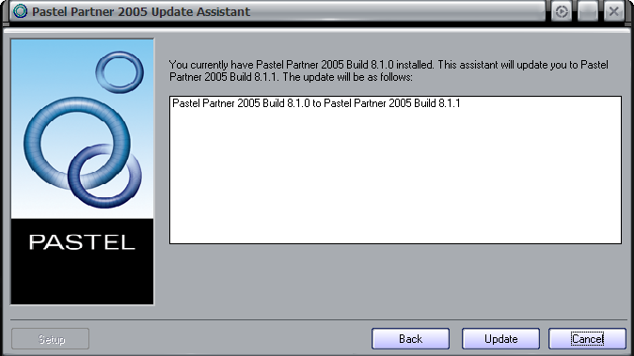

- Should you have downloaded more than one update, they will all appear in the screen above.
- Once you click on the update button, the update will proceed and a progress bar will appear for each.
- Once you click on the next button the confirmation screen will appear to inform you whether the update was successful or not.

NOTE: The update folder does not have to be on a local drive and can be added to a server where which each workstation can map a drive to. The Update Assistance will then use the RTP files located on the server to update from.

