Category: Using Pastel without a Mouse
___________________________________________________________________

Product: Pastel Accounting Xpress and Partner

Using Function Keys in Pastel:

Use the function keys listed below to navigate your way through Pastel without a mouse.
Function Key | Operation
F1 | Access the help menu anywhere in Pastel.
F2 | Open the note Facility.
F3 | Allocate open item transactions whilst on a Batch allocation screen in the journals.
F4 | Open the Price Search facility.
F5 | Zoom for a record. This opens a Zoom screen from which you can perform various record editing and enquiry functions, discussed below.
F6 | Add a new record.
F7 | In Process -> Cash Books, reconcile cash book transactions (Bank Reconciliation).
F8 | In Process -> Cash Books and Process Journals, switch from entering an amount inclusive or exclusive of tax or vice versa.
F9 | Open the calculator.
F12 | Return to the previous column in most processing screens, without validating the code.

Shortcut Keys:

Using shortcut keys can also speed up the invoicing and line editing process. Useful shortcut keys are:
Shortcut Keys | Operation
<Ctrl> + H | Insert headers on invoices.
<Ctrl> + L | Insert lines on invoices.
<Ctrl> + F | Insert footers on invoices.
<Ctrl> + R | Copy the address details between Postal and Delivery address fields.
<Ctrl> + U | Initiate document user defined fields

Navigation Shortcut Keys:

Using Navigation Shortcut Keys can also speed up the process of moving between records. Useful Navigation shortcut keys are:
Shortcut Keys | Operation
<Ctrl> + <Enter> | Save.
<Ctrl> + <Page Down> | Next record.
<Ctrl> + <Page UP> | Previous record.

Zoom Facility
The Zoom facility is a function that lets you select, enquire on, and edit, master file records. You use it to quickly search for records, perform record enquiries, edit existing records, and create new records.
What makes the Zoom facility so useful is that you can access it whenever you can enter a code for that master record. You do not have to close the function in which you are working, and you do not have to access a menu option. You invoke the Zoom facility within the data entry field itself.
You access the Zoom facility in one of two ways:
- Click the Zoom icon on the right of master-file data entry fields. The icon looks like this ->. .
- Select the View…Zoom menu option, and then choose the file you wish to view.
When you invoke the Zoom facility, the system displays a screen of records. You can scroll through the records to find the record you require.
To navigate the record list:
- In the Zoom Sequence frame, you can choose the sequence in which the system displays the records. This varies by master file, but usually includes the code and the name or description.
- Use the <Up Arrow> and <Down Arrow> keys to scroll a line at a time. With a mouse, click the arrows on the scroll bar.
- Use the <Page Up> and <Page Down> keys to scroll a page at a time. With a mouse, use the scroll bar.
- In the Zoom From field, you can enter the first letter of the record you are looking for. As you do so, the system scrolls to the nearest record that matches the character you enter. Note that the system applies the letters you enter to the Zoom Sequence field.
- You can search for a record by entering any text that the record contains. For example, you can find a customer by entering their telephone number. To do this:
- To do this, click on the Find button. The Find frame replaces the Zoom Sequence frame.
- In the What to Find field, enter the text such as the telephone number.
- To find the first record that contains the text, click the Find First button. The system searches every record in the zoom sequence, and stops when it finds the first record that contains the text.
- To find every record that contains the text, click the Find All button. The system searches the whole file and displays each record it finds that contains the text. Once you see the record you require, click the Stop button to halt the search.
Once you find the record you require, you can do a number of things:
- To select the record to use in the function from which you invoked the Zoom, press <Enter> or click the <Enter>=Select button.
- To perform an enquiry on the record, press <F5> or click the <F5>=Enquiry button. This lets you view master file information, see balances, access notes, and view various reports.
- To add a new record, press <F6> or click the <F6>=Add button. If you wish to add records, a quicker method is to invoke the Add facility from the data entry field.
- To modify the record, press <F7> or click the <F7>=Modify button.

Here is a screen shot of the General Ledger Zoom screen.

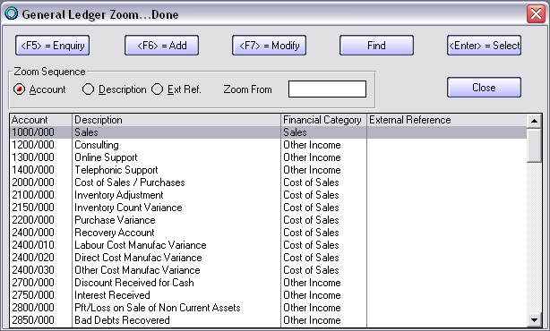
.

CONTACT US

If you have any further questions, contact us on:
T: 0860 PASTEL or (011) 290 2880
E:support@pastel.co.za

