Category: Using barcodes in Pastel
___________________________________________________________________

Product: Pastel Accounting Xpress and Partner

Pastel allows you to make full use of barcodes. However, their use is entirely optional. To make full use of the barcode feature, you will need to purchase barcode scanners that can place barcode numbers into the keyboard buffer. Barcode processing works as follows:
- For each inventory item, you can enter a barcode of up to 15 characters. The barcode does not have to be unique for each inventory item.

- If you need to, you can print barcode labels for items in the View, Inventory and then Print Labels menu option.

- When you process Customer and Supplier documents, you can choose to identify inventory items by means of their barcode rather than their inventory code. You can then either type in or scan in the barcode. If there are multiple items with the same barcode, Pastel displays a list of the inventory items and you can choose the one you require.

Putting Barcodes into the Inventory Code Field

Instead of using the barcode field to store the barcodes, you can also use the item code field. Then you always access the item via its barcode. However, there are two reasons that may prevent you from doing this:

- If the barcodes you use are not unique, in other words if there is more than one item which uses the same barcode, you cannot use this facility. Item codes are unique, whereas barcodes are not.

- If you have your own codes for inventory items, separate from their barcodes, which you use to identify them, then you would probably want to use these codes in the inventory code field.

Below is an example of how to set up your own barcodes:
- Go to Edit and then select Inventory and then Item File.
- Click in the barcode field and using the scanner, scan the product (i.e. the barcode off a can of cold drink for instance)

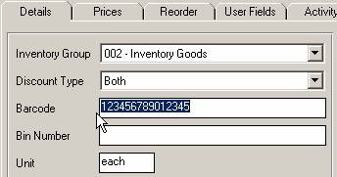

- The Barcode will insert itself in the Barcode field.
- To print the label, click on View and then Inventory. Now select Print Labels. This option lets you print inventory labels. You can print one label for each inventory item, or you can print a label for each quantity of the item on hand, or a label for each item in a range of goods received notes or supplier invoices.

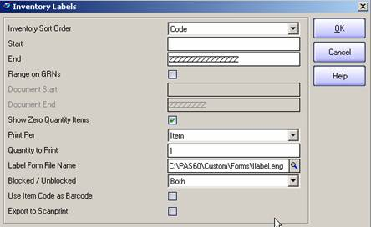

- You can print barcode labels in many standard formats, on any printer. Pastel ships with some standard label formats, but you can change the layout or even create new layouts. You do this in the Forms Designer facility. Use the search to look for help on ‘labels’ facility.

- Once the labels have been printed you can now use this on the actual stock items. At time of Sale you can now use the barcode scanner to read the item. Select Barcode on the Document Type Field.

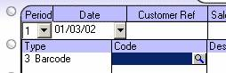

CONTACT US

If you have any further questions, contact us on:
T: 0860 PASTEL or (011) 290 2880
E:support@pastel.co.za

