Lesson 4

Installation and Registration

Lesson Objectives
In this lesson you will learn how to install your Pastel Partner 2005 programme and how to register same. You will also be shown a couple of enhancements and additional features that are available.
Learning Outcomes
At the end of this lesson you will be able to:
- Install your software.
- Register your package.
- Troubleshoot your registration process.
- Know where to locate enhancements and additional features in the programme.

Now that you have purchased your software the first thing you need to do is install it. First, you will need to check that your system meets the hardware and software requirements to run Pastel Partner effectively and achieve maximum performance from this software.
In this lesson we look at how you would install your Pastel software in a single user or workgroup environment . In these types of environments, Pervasive software installs automatically and the number of users (eg 1 or 5) will be activated at the time of registration.

This lesson is broken up into the following sections:
A Hardware Requirements
B Installing your Pastel Partner 2005 software
C Registering your package
D Pervasive database
E Enhancements in Pastel Partner 2005
F Additional Features

Before you can install Pastel Partner you need to ensure that your computer hardware meets the necessary requirements.

A | Hardware Requirements

Pastel Partner 2005 requires a computer equipped with a CD-ROM.

For a single user version or a workstation on a multi-user version, the minimum requirements are:
- 256 MB RAM
- 256 Screen Colours
- Pentium III

For a Server the minimum requirements are:
- 512 MB RAM plus 128 MB RAM per user – for example, a 10 user would require 1,5 GB RAM.
- 256 Screen Colours
- Pentium IV

Pastel Partner 2005 will run on the following operating systems:
- Windows 2000
- Windows XP Professional SP2
- Windows NT SP 6
- Windows 98 Second Edition

Note 1 You CANNOT use Microsoft Windows XP Home in a network environment.
Note 2 It is recommended that if you have 10 workstations logged on simultaneously with large volumes of data being processed that you run in a Pervasive Client / Server environment as opposed to a Pervasive Workgroup environment. The obvious advantage to this is the speed at which processing will be able to take place.
Note 3 If you are upgrading from an earlier version, do not install Partner 2005 in the same directory as the older version as this could cause data corruptions. Use a new directory instead.

We will now install the software.

B | Installing the Pastel Partner 2005 Software

 | 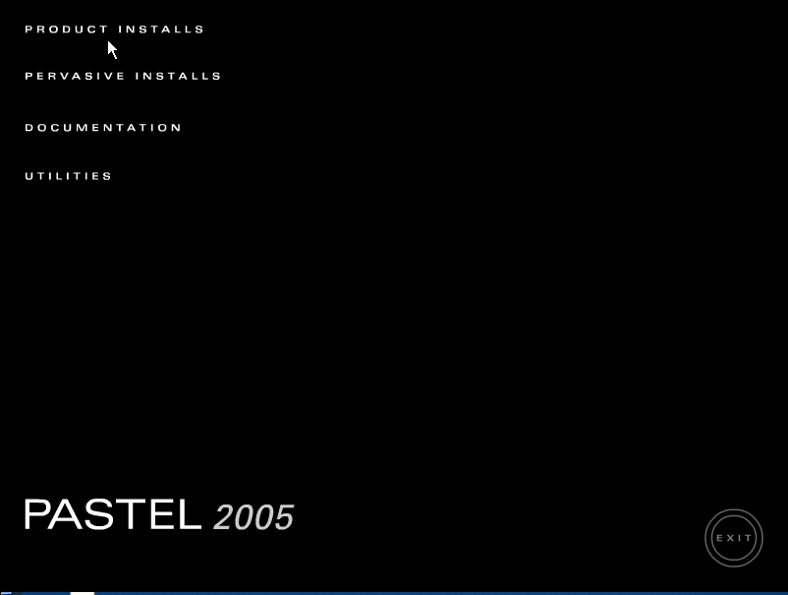 | - Place the CD in the CD-ROM drive. The CD should start up immediately. The following screen should display.
 |  | - Click on PRODUCT INSTALLS. The following screen displays.
 |  | - Move your mouse over the product names until the one you require lights up. Note the logo for that product will form while the mouse is on the product name.
 | 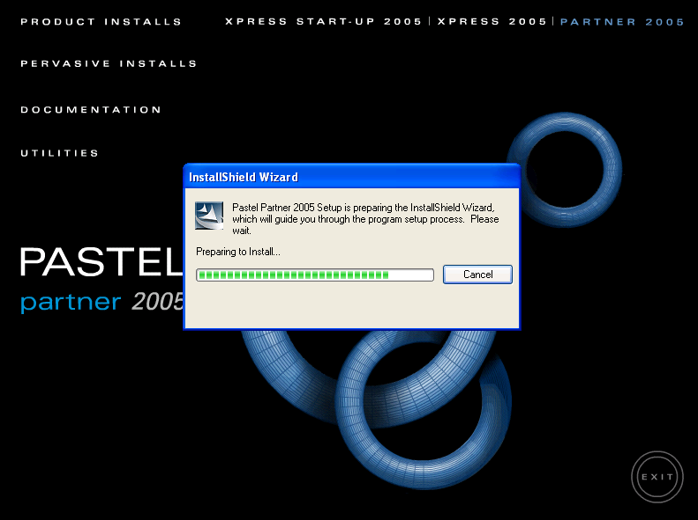 | - Click on the relevant product name. The InstallShield Wizard will now install.
 | 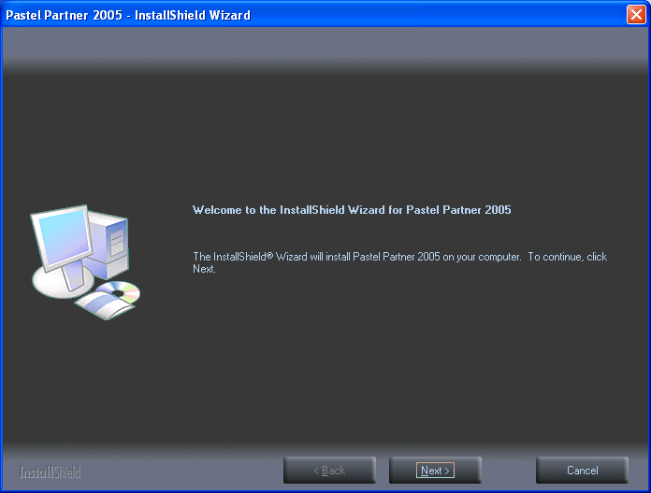 | - When the InstallShield has finished installing the following screen will display.

 | 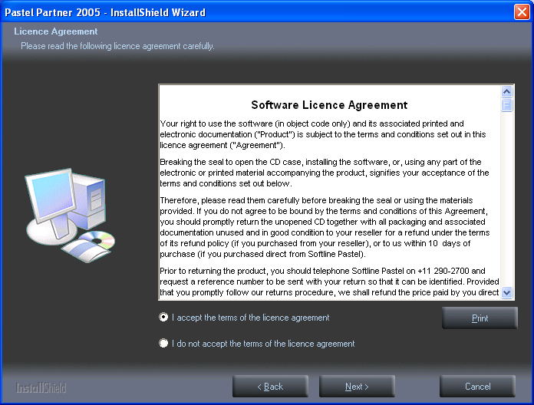 | - Click on Next. The Licence Agreement screen will display.
- After reading through the Agreement click on the option “’I accept the terms of the licence agreement.”. If you do not follow this option the programme will not continue loading.
Note: There is an option to print out the agreement if you so wish.

 | 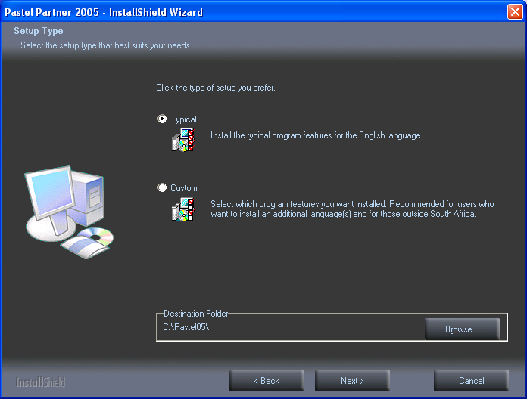 | - Click on Next. The Setup Type screen displays.
 |  | - If you want to install additional languages or language specific demo companies, select the Custom option. We will select the Typical installation. Pastel will load to your local drive (C drive) as a default. If you wish your software to load to a different drive click on the browse button and select the required drive. We recommend that you install into the default folder.
 | 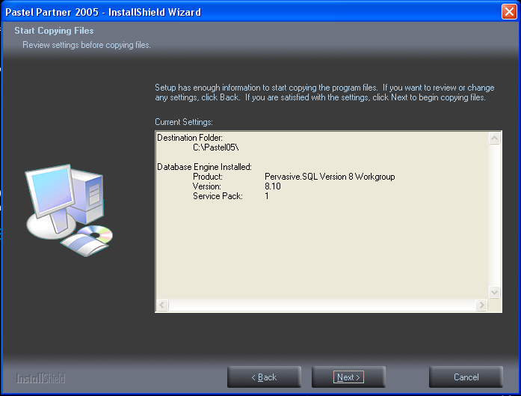 | - Click on Next. The following screen displays. This screen shows you what drive the software is going to be installed to and what database engine is installed.
 | Pastel uses the Pervasive database engine which other software may also make use of. If an existing installation of Pervasive is present the Pastel installation will not replace Pervasive because it may render other software unusable. Should you encounter this situation you should first check the compatibility of the Pervasive version with your other software products.
 | 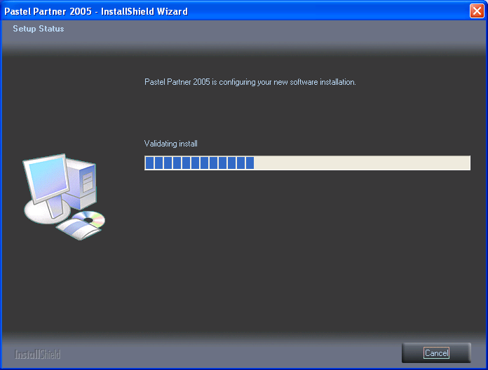 | - Click on Next to continue with the installation. The following screen showing the status of the setup will display.

 | 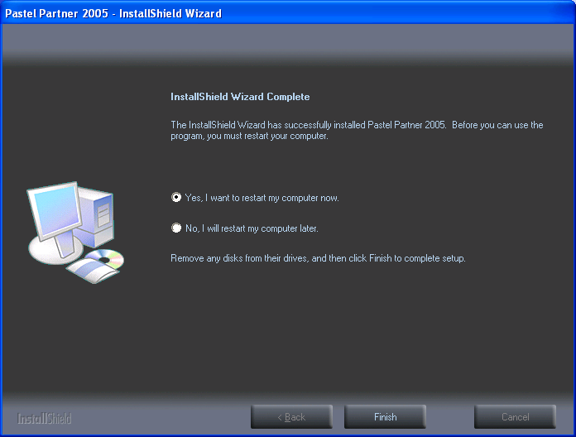 | - After the files have successfully copied the following screen displays.  - Select the option “Yes, I want to restart my computer now”.
- Click on Finish. If you do not select this option and click Finish the following screen will display.

- Click on Exit to complete the Setup. You will still require to restart your computer before you begin using Pastel Partner 2005.

You have now completed an installation for a new computer. From time to time Pastel releases upgrades of their software. It is a good idea to update your system regularly as these upgrades contain enhancements and fixes which will streamline your continued use of the software.

If you have subscribed to Pastel Cover you can download an upgrade from the website or collect a new CD from the Pastel offices.

You will notice that the Pastel Partner 2005 icon appears on your desktop.
We will now double click on this icon to launch the programme.

C | Registering Your Package

When you first launch Pastel you will be prompted to register your software. You will have to register your package before you can make full use of it. If you do not, the package will remain in the demonstration mode for 200 entries or 30 days whichever happens first. All work that you have done during this demonstration period will be retained. Registration is an annual activity.

 | 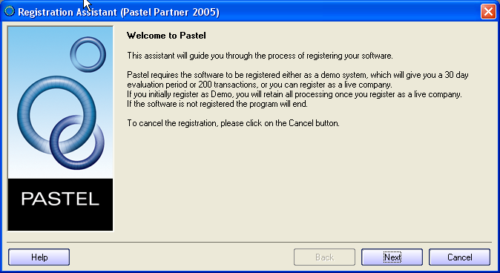 | - The Registration Assistant will guide you through a series of screens. The first screen is shown.
 | 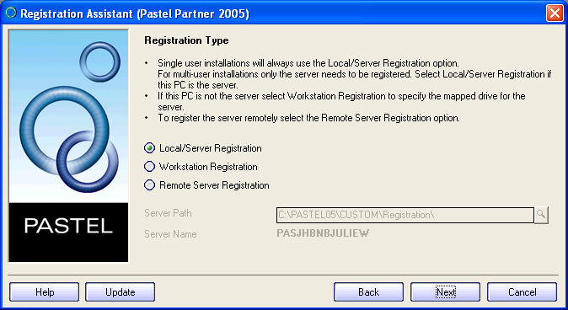 | - Click on Next. The following screen will display.
The first prompt is to ask you what type of registration you will be doing.
- Local/Server Registration is for single user installations or the server of a multi-user installation.
- Workstation Registration is used for linking workstations to a multi-user registration.
- Remote Server Registration is used to register a multi-user version where the server is a non-Windows server. This will use the workstation you are on to write registration information onto the non-Windows server after which you can register workstations in the normal manner.

 | 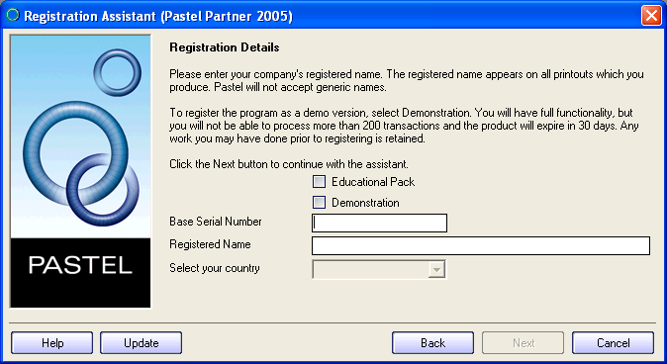 | - Once you have made your registration selection (in your case Local/Server), click Next. The following screen will display.
You will be asked to enter your serial number, registered name and the country in which you are registering your Pastel software.

The different registration processes are as follows:
- Demonstration Mode – gives you 30 days comprehensive access to the software.
- Educational Mode – allows you 3 – 6 months limited access to the software. This type of registration is intended for long-term students who require more than the 30 day window. In educational mode you will not be able to change company details as they have been pre-loaded.
- Registration of a live version.
  - On-line registration – registers your product and unlocks modules purchased.
  - Telephone registration – you can call Pastel and register your details telephonically.

The first method of registration we will show you is the Demonstration mode.

Registering the Demonstration Version

 | 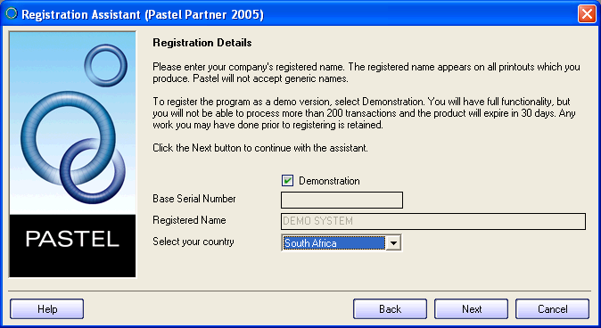 | - To register a demonstration version, check the Demonstration check box. The Select your Country list box activates and you can choose your country.

 | 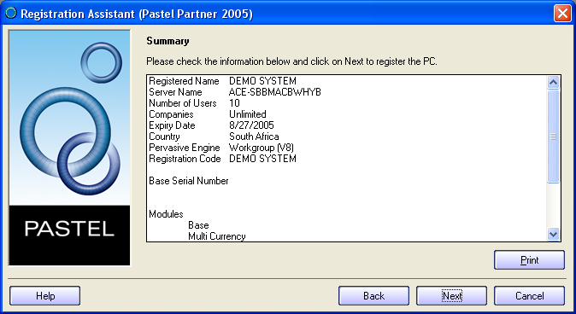 | - The Assistant will skip to the final screen.  - Click on Next.
 | 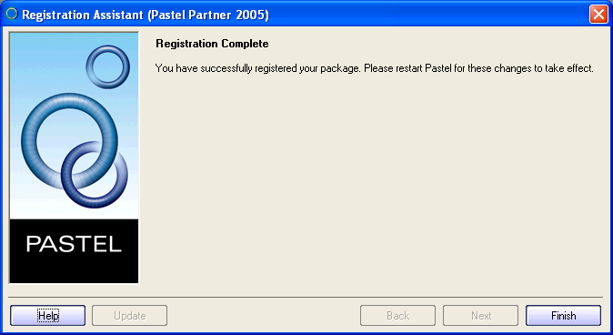 | - The following screen displays informing you that you have successfully registered your package.  - Click on Finish and restart Pastel for the changes to take effect.

Registering the Educational Version

 | 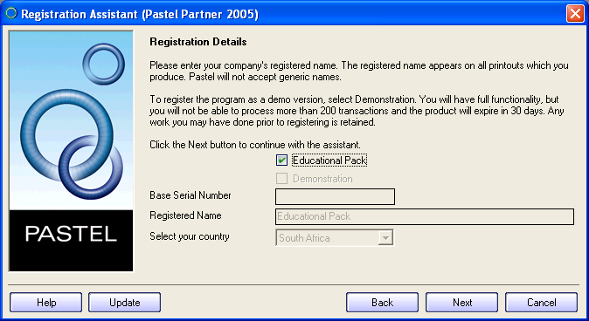 | - To register an Educational Pack version, check the Educational Pack check box. Automatically the software will register as an Educational Pack for South Africa.

 | 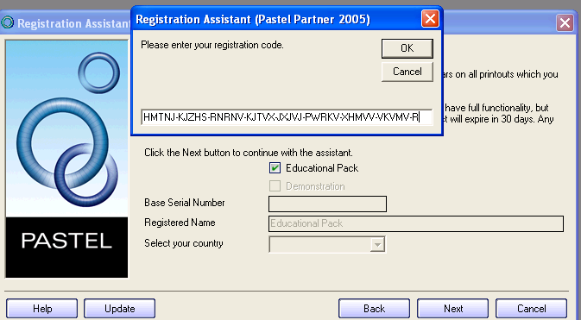 | - Now select Control, Shift T – a pop up registration box will now appear. Please ask your training instructor for the 41 ABC character unlock code. These codes are unique to your training environment.
 | 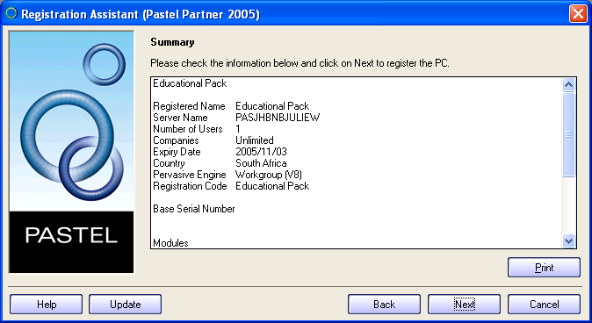 | - Enter the code and click on Next. A similar screen to the oppposite one should display.  - Click on Next.
- The following screen displays informing you that you have successfully registered your package.

- Click on Finish and restart Pastel for the changes to take effect.

Registering the Live Version

You can either phone into the Pastel registrations department or you can register on line.
We are going to take you through the method of registering on line.

On line Registration
You must be connected to the internet to follow through with this method.

 | 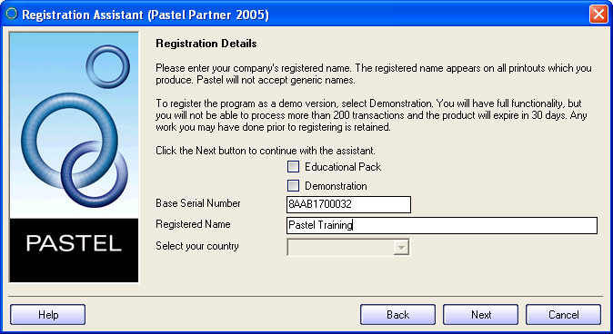 | - Insert your base serial number and the registered name you wish to use. Pastel will recognize the country of registration from the serial number you enter.  - Click on next.

Tip When choosing your registered name, remember that if you have more than one company on your database it might be advisable to choose the name of a person, that is, the accountant or owners name instead of a company name. Remember that whatever name you choose is the name that will appear on the top of all your reports and financial statements, for example, Trial Balance prepared by ……………. You obviously would not want one company’s financial statements stating that they were prepared by another company.

 | 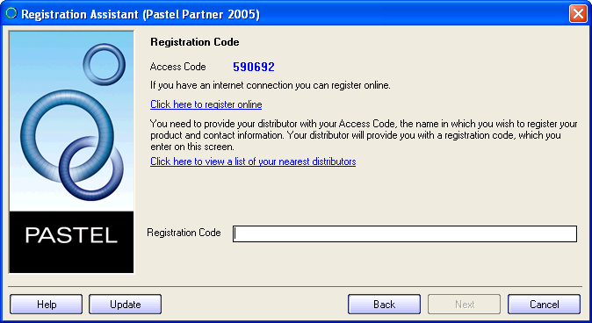 | - You will now receive an access code that is unique to your installation. Click on the “Click here to register online”

Note: If you wish to do a phone in registration, you will be required to quote this access code in order to receive the 41 character authorization code.

 | 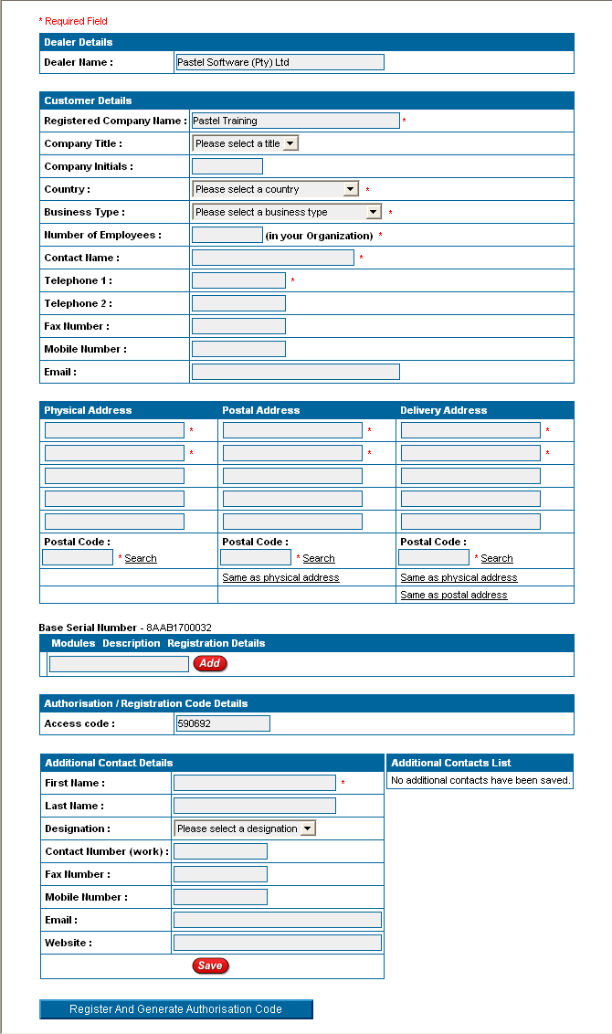 | - You will be taken to the Pastel online registration screen, where you will be required to enter all your company’s details.  It may take a few minutes to load…  If you don’t know your postal codes, the online registration system give you the option to search for either a suburb, town, box postal or street postal number.

 | 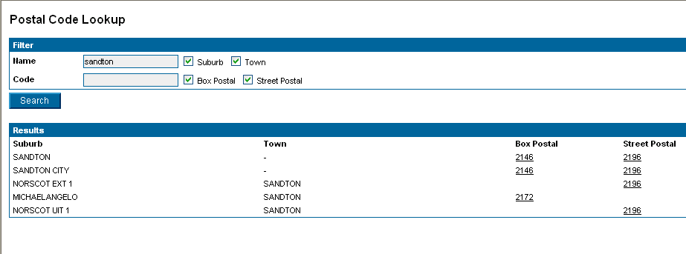 | - The Postal Code Lookup screen is shown. The name Sandton was entered and all tick boxes were left as per the default.
 | 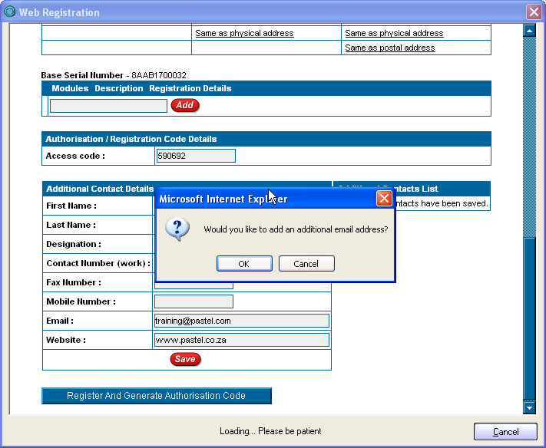 | - Click on the correct postcode, you will then be returned to the form to type in the remaining details.  - Once you have completed all the details – click on “Register and Generate Authorisation Code”
 | A prompt screen will ask if you would like to add an additional email address. If you only have one email address and this has already been entered, click cancel. Alternatively select ok, and type in an alternate email address.

 | 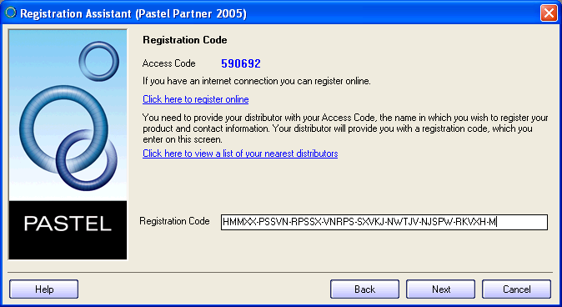 | - You will then be returned to the Registration Assistance and the 41 Character installation code will automatically be inserted.
 |  | - Click next. The Registration details will then be confirmed. It is a good idea to print these and keep them for reference.
 |  | - Click on Next. You will be prompted to complete the process by allowing the system to restart your computer.

You have now successfully installed and registered your product.

Troubleshooting
If you are having trouble registering your software, please check the following:
The date on your computer is set to the correct date.
To do this, you will need to place your mouse cursor over the time display in the bottom left corner of your screen. A small box will pop up displaying the date that your computer is set to. If your date setting is incorrect, right click on the time display, select the Adjust Date/Time option and change your date setting.
The name entered on your registration form online is exactly the same as the name entered on the Softline Pastel product registration screen within your software.
The Softline Pastel product registration screen within your software, is case sensitive. Therefore, where you have made use of uppercase letters, special characters and spaces on the form you filled in on this site, you will have to use the same uppercase letters, special characters and spaces when filling in your details on the product registration screen.
If you are still unable to register your product, please contact the Softline Pastel Registrations Team on +27 11 290 2770 or e-mail registrations@pastel.com.

D | Pervasive Database

When starting your Pastel program you will see an icon at the bottom of the screen that says Pervasive Database. Pastel uses a separate database engine that serves out the information that you have put into your data files. This Pervasive database will follow the opening and closing of the Pastel program and you will normally not have an awareness of its background operations. However, should you be booted out of the program for any reason you would need to close this engine manually before you try to reopen the Pastel program. Failure to do this will result in your receiving the following error message Password in use. Simply close the Pastel program, go back to your desktop menu and click on the Microkernel Database icon on the task bar and close the program under the File menu. You can then restart the Pastel program.

E | Enhancements in Partner 2005

For all the new features that are available on Partner 2005 click on the Help…What’s New in Pastel Partner 2005 menu option to access this help file.

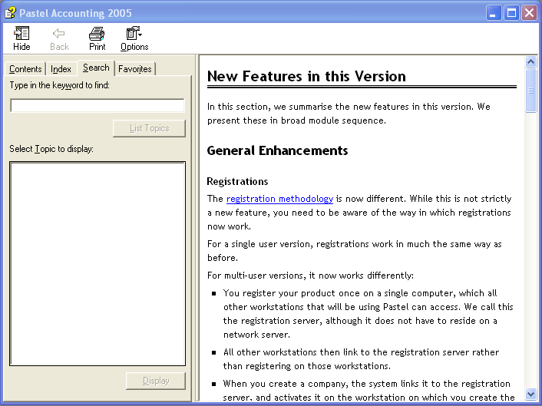

In your own time read up about these various options as they are very relevant to the usage of this software.
H | Additional features

Tip of the Day
If you would like to receive a Partner 2005 “Did you know…” tip each time you start the program, go to Help…View Tip of the Day. Select the Show tips on Startup check box and then when you open your company you will have a different tip displayed each time.

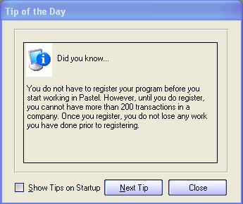

Open Last Used Company on Startup
Another time saving feature is to initiate the Open Last Used Company on Startup. When you open a company place a tick in the relevant box as displayed below. Then when you open up Partner 2005 the company that you last worked on will display straight away.

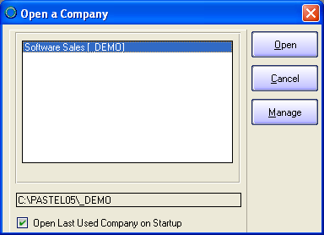

Electronic User Manual
A full user manual in PDF format is available under the Help…Documentation section of the programme.

Log a Support Incident
If you are connected to the internet you can select to Log a Support Incident under the Help menu and you will be directed straight to the Customer Zone on the Pastel Website.
This feature will be discussed in detail in Lesson 5.

You have now learnt how to install and register your package and been shown a few interesting features. In the next lesson we will use the demonstration set of accounts to illustrate the functionality of the package and how to navigate around the software.
Formative Assessment
- What hardware and operating system is required to run Pastel Partner on a single user system? (5 marks)
2. Why should you not install Partner 2005 in an old Pastel directory? (2 marks)
3. Name the methods of registering your software? (2 marks)
4. Identify one problem that could prevent you from registering your software. (2 marks)
5. Name the database used by Partner 2005? (1 mark)
6. How can you identify new features in Partner 2005 quickly? (1 mark)
7. Describe how you can get Partner 2005 to automatically open the company that you last worked on. (1 mark)

8. True / False? There is a full electronic user manual available with your software. (1 mark)

Assessment Score – Lesson 3
15
Notes

