

Solution for the Error Message: “the maximum number of companies that can be created has been exceeded” when you are creating companies in Pastel Xpress Start Up.

Pastel Xpress Start Up entitles you to the creation of one company only. The Demo company is
the default company that ships with Xpress Start Up. If you have more than one company present
in Xpress Start Up, and are unable to activate any of your companies using the Manage button,
you will first need to ensure that you have only one company other than the Demo company in
the Xpress05 folder. In order to check this you would need to do the following:

- Right click on the Start button on the bottom left hand side of your screen and select the Explore option.

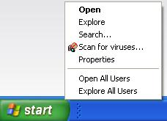

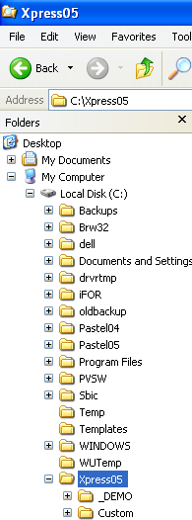

- Locate the Xpress05 folder under your local drive (normally C:\) and expand this folder.
- Directly beneath this should be a folder called DEMO_ and a folder called CUSTOM.
- There should be only one other company folder. If there is more than one you will not be able to activate any of the companies listed.
- You will need to decide which company you want to keep. In order to eliminate any problems, our recommendation is to make backups of these folders before deleting anything.
- If you do not want to delete these folders you can create another folder on your local drive and move the unneeded company folders into that one.
- Please make sure you move only the company folders and not any of Pastels default folders in the Xpress05 folder.

Contact us
If you have any further queries on this topic, contact our support department on:

T: 0860 PASTEL / (011) 290 2880
E: support@pastel.com

