Category: Match Open Item
___________________________________________________________________

Product: Pastel Partner and Xpress

When using Open Item Customers or Suppliers, you have to allocate payments to specific invoices. Usually, the Open Item screen will be invoked in the cashbook when processing the payments or receipts. However, sometimes you need to be able to match the Open Item transactions after you have updated the batches or you need to be able to change the matching of some transactions.

- In Pastel, go to Process and the select Match Open Item.

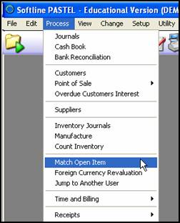

- Select the relevant customer or supplier and the correct period.
- You will see a value for Unallocated, followed by a list of Invoices which have yet to be matched.

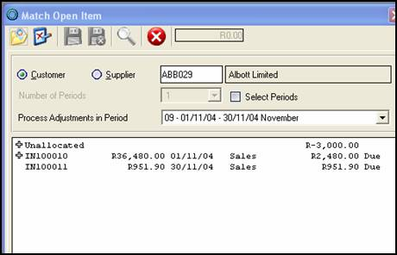
Unallocated

- The Invoices not yet matched, will have an amount due.
- Click on the + sign next to the Unallocated option to view all amounts not yet matched.
- Select on the amount you wish to match. Upon doing this you will see that the cursor changes to a horizontal bar with arrows on each side.

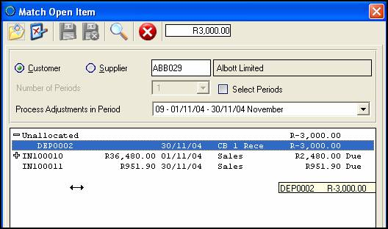
Cursor changes to a horizontal bar

- Scroll down the list of invoices still showing due, and click on the one you want to match the payment to. You will now have a 0.00 balance for that invoice.

Note: As you move your mouse down the page, the amount moves along with it.

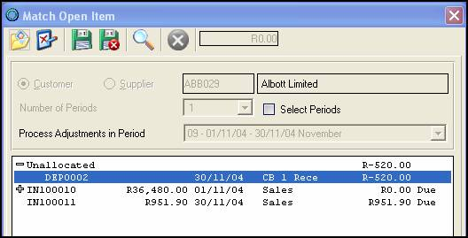

Un-matching a transaction

- Should you wish to un-match a transaction, click on the + sign next to the invoice in question.
- This will reveal the payment/receipts amount matched to the invoice. Click on the amount and move your mouse up the page to Unallocate.
- Click on the Unallocate option to drop the amount here, thereby unallocating the transaction.

Note: You will not be able to leave the screen until you have selected to either save or discard the changes you have made.

CONTACT US

If you have any further questions on this topic, contact our support department on:
T: 0860 PASTEL or (011) 290 2880
E:support@pastel.com

