Installing Microsoft Data Access Components (MDAC)

In certain instances you might not be able to install your Pastel 2005 package due to installation runtime errors. To fix this problem, you may need to install the Microsoft Data Access Components (MDAC) from the CD. This document provides the steps you need to follow.

- Browse the Pastel 2005 CD using Windows Explorer

- Navigate to the Util folder, and into the Mdac folder.

- There are two sub-folders: V27 and V28. Double-click on the V28 folder.

- Double-click on the file mdac_typ(.exe).

- After the files have been extracted, check “I accept the terms of the preceding license agreement” and click on NEXT.

- Click on FINISH to install Mdac version 2.8.

- Once the setup is complete, click no CLOSE.

- In the Windows Explorer, go to the V28 folder, and double-click on the file mdac_typ(.EXE).
  - If you are running Windows XP Service Pack 2, you might get a message that MDAC version 2.8 is incompatible with your version of Windows. When you do, simply click on Cancel to exit the installation.

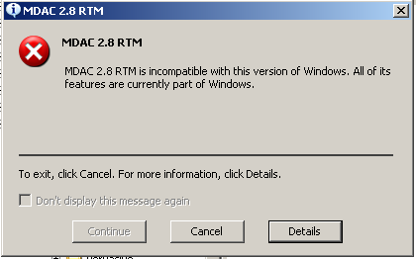

  - If you do not get the message, follow steps 5 – 7 to complete the installation.

- This will complete the installation of MDAC. Restart your computer before continuing.

Contact us
If you have any further queries on this topic, contact our support department on:

T: 0860 PASTEL / (011) 290 2880
E: support@pastel.com

