Category: Changes in Error Messages for Xpress and Partner 2007

___________________________________________________________________

Product: Pastel Accounting Xpress and Partner

In Pastel Xpress and Partner 2007, we have changed the wording of the error messages in an attempt to make them more understandable and easier to troubleshoot. Below is a list of the old and new messages.

Current Message | New Message
Income/expenditure account not setup | 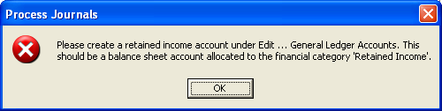
Error Code 20 | 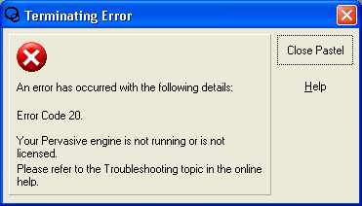
Your Company has been tampered with. | 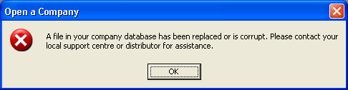
Status 30 | 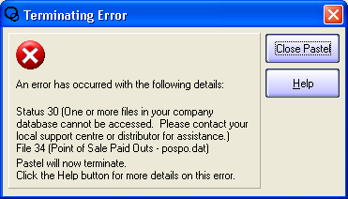
Status 22 | 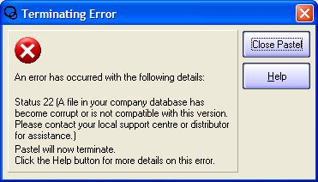
Runtime error 62 | 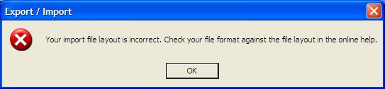
There is no Open Item record for transaction number xxx | 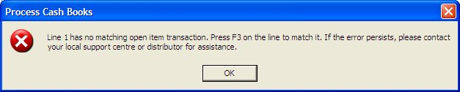
Your system has unallocated accounts. Cannot Continue. | 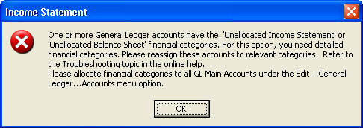
Invalid Format in File… | 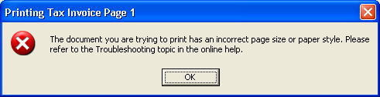
Status 161 | Your Pervasive License User Count has been exceeded. Please contact your local support centre or distributor for assistance or refer to the Troubleshooting topic in the online help.
Status 116 | There is a network communication error. Please contact your local support centre or distributor for assistance or refer to the Troubleshooting topic in the online help.
Runtime Error 429 | Pastel has encountered a problem with a required file or component. To resolve this, from the Windows taskbar click Start…Programs…Softline Pastel…Pastel Partner/Xpress 2007, and select the components utility.  Note : This message only appears when opening Pastel if the error occurs elsewhere in the program the message remains as is.
Runtime Error 430 | Note : This message only appears when opening Pastel if the error occurs elsewhere in the program the message remains standard.  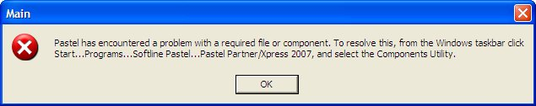

CONTACT US

If you have any further questions, contact us on:
T: 0860 PASTEL or (011) 290 2880
E:support@pastel.co.za

