Bank Reconciliation in Pastel Xpress 2005/Pastel Partner 2005

The Bank Reconciliation functionality has changed slightly in the new version of Pastel 2005. This document provides an overview of the change and how the enhancement will help your business.

The system now allows you to save your reconciliation without updating it in the system. Therefore, you can now tick your transactions as reconciled, but they will not be updated in the system when you close the recon as previously. On your return to the bank recon, you will find the transactions you ticked as reconciled there and can make changes if necessary.

When you are satisfied that your reconciliation is in balance, you now need to update the recon by clicking on the UPDATE button on the Bank Reconciliation which will then update the transactions as reconciled in the system.

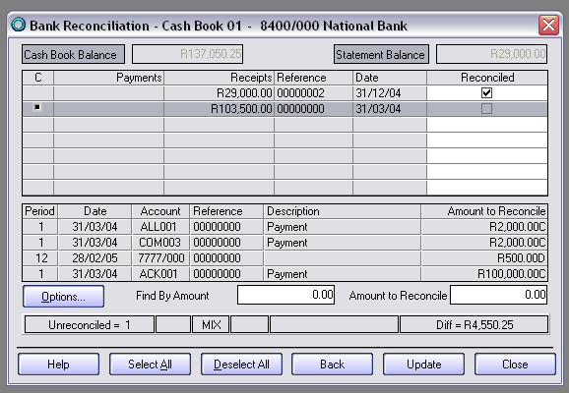

If you don’t UPDATE the Bank Reconciliation, the transactions will appear in your following month together with your current transactions, and will consolidate the transactions where the same reference number was used. Therefore, it is very important to UPDATE the Bank Reconciliation on completion of every month.

Contact us
If you have any further queries on this topic, contact our support department on:

T: 0860 PASTEL / (011) 290 2880
E: support@pastel.com

