Category: Backup: Create new folder option

___________________________________________________________________

Product: Pastel Accounting Xpress and Partner

One of the new features in Pastel Partner 2007 and Pastel Xpress 2007 is the ability to create a folder within the Backup Assistant.

It is recommended that you keep at least 3 sets of backup per week. This is dependent on the amount of processing that you do. If you do a lot of processing, you may need to keep a backup for every day of the week.

In previous versions of Pastel, you either had to constantly overwrite your previous backup; or you had to create a folder via Windows Explorer for every backup that you made. With Pastel 2007, this hassle has been removed with the New Folder option.

For the purposes of this example we will assume that you wish to create a folder on your C: drive called Partner07Backups, and in that folder, have a subfolder for each day of the week. You want to backup your company every day to the relevant folder.

- Click on File and then Backup.
- Navigate to a folder in which you want to save your backups to (eg C:\).
- Click on the New Folder button.
- Type in Partner07Backups and click on Create.
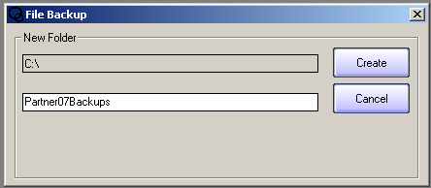

- The folder is then created, and is selected.
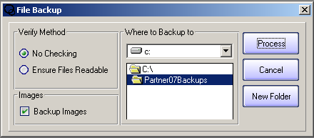
You may now create a subfolder for Monday’s backups.

- Click on New Folder again, type in Monday, and click on Create.
- The folder Monday is created as a subfolder of Partner07Backups. 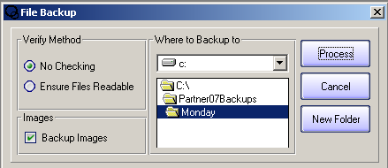
If you want Pastel to make the backup into this folder, click on Process.
- Pastel will create a ZIP file containing your data files into the folder C:\Partner07Backups\Monday.

If you wish to copy your backups to a CD or Flash Disk, you can use Windows Explorer or your CD-Burning software to copy the entire Partner07Backups folder.

This is one of the great new features of Pastel 2007. Other great features to look out for include:
- The new Explorer
- ‘Jump To’ Open Batches function
- Reprinting customer and supplier documents from Drill Down
- Export filters
- 1 & 2 cent rounding on documents

CONTACT US

If you have any further questions, contact us on:
T: 0860 PASTEL or (011) 290 2880
E:support@pastel.co.za

